Intro to Programming

**Assessment 2: Utility App**

|  |  |
| --- | --- |
| **Student’s Name** | Daniel Elmer Coching Magalang |
| **Roll No** | 2023-827 |
| **Github Repository Name** | IntroToProgramming-CCL4/ **assesments-d07zer** |
| **Github Repository Link** | https://github.com/IntroToProgramming-CCL4/assessments-d07zer/tree/db9ee6ada50869ec89aadb6e5428fe4692cc1170/Assessment%202 |
| **Repository Screen Shot** |  |

**The Development Document**

In this assessment, I was tasked to code a Utility App that is a Vending Machine where you're given a budget for purchasing this specific item and returns a receipt upon purchase. The features of the vending machine I designed myself is relatively simple. Its unique feature consists of it having multiple pages holding varieties of goods to select from. These pages in question are divided into specific categories, such as a section for dispensing Hot Drinks, or any Readymade meals. The user can choose to interchange between these pages before proceeding with their purchase.

**The Flowchart**

Below is the set of flowcharts for each one of the vending machine's contents that run it's entire functionality. These are multiple separate flowcharts for each parts that make up the entire program. Each have been labeled (Such as the purchase process, or returning of receipt, budget, etc.) for convenience.

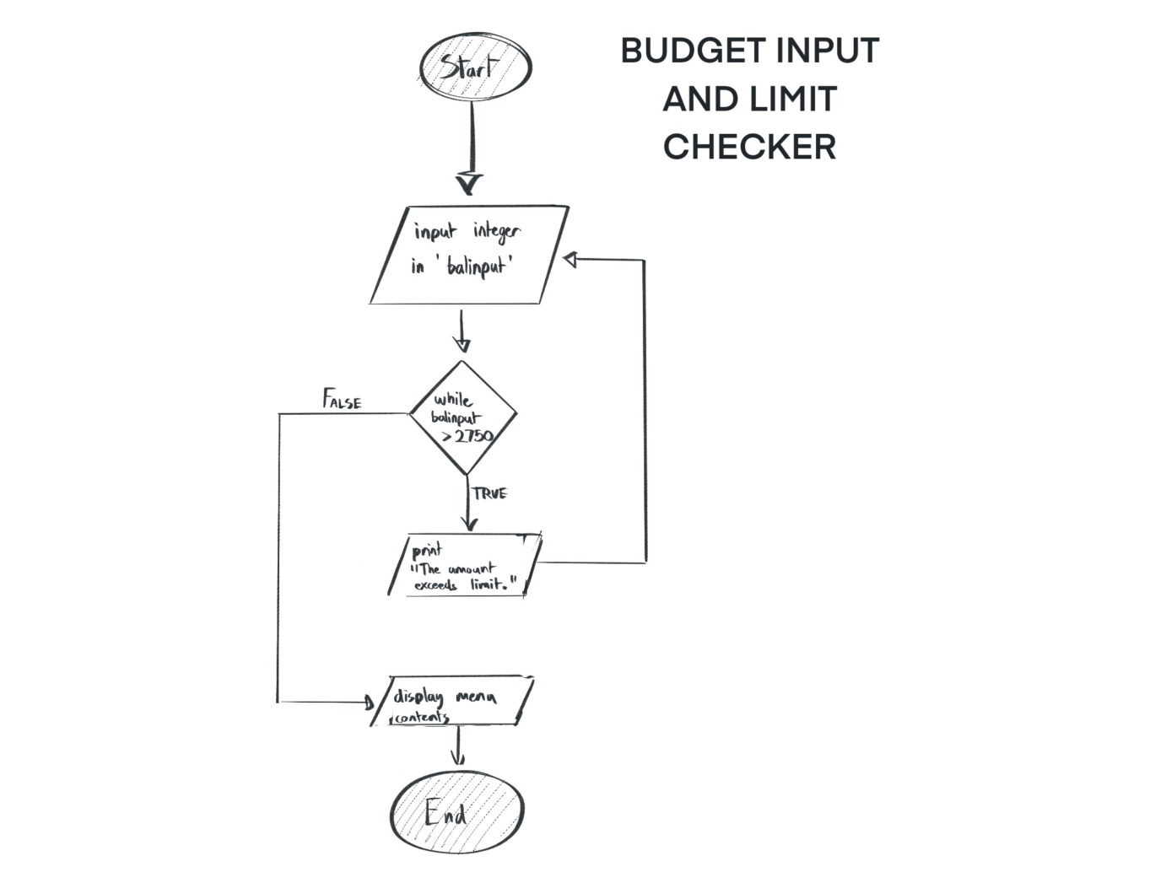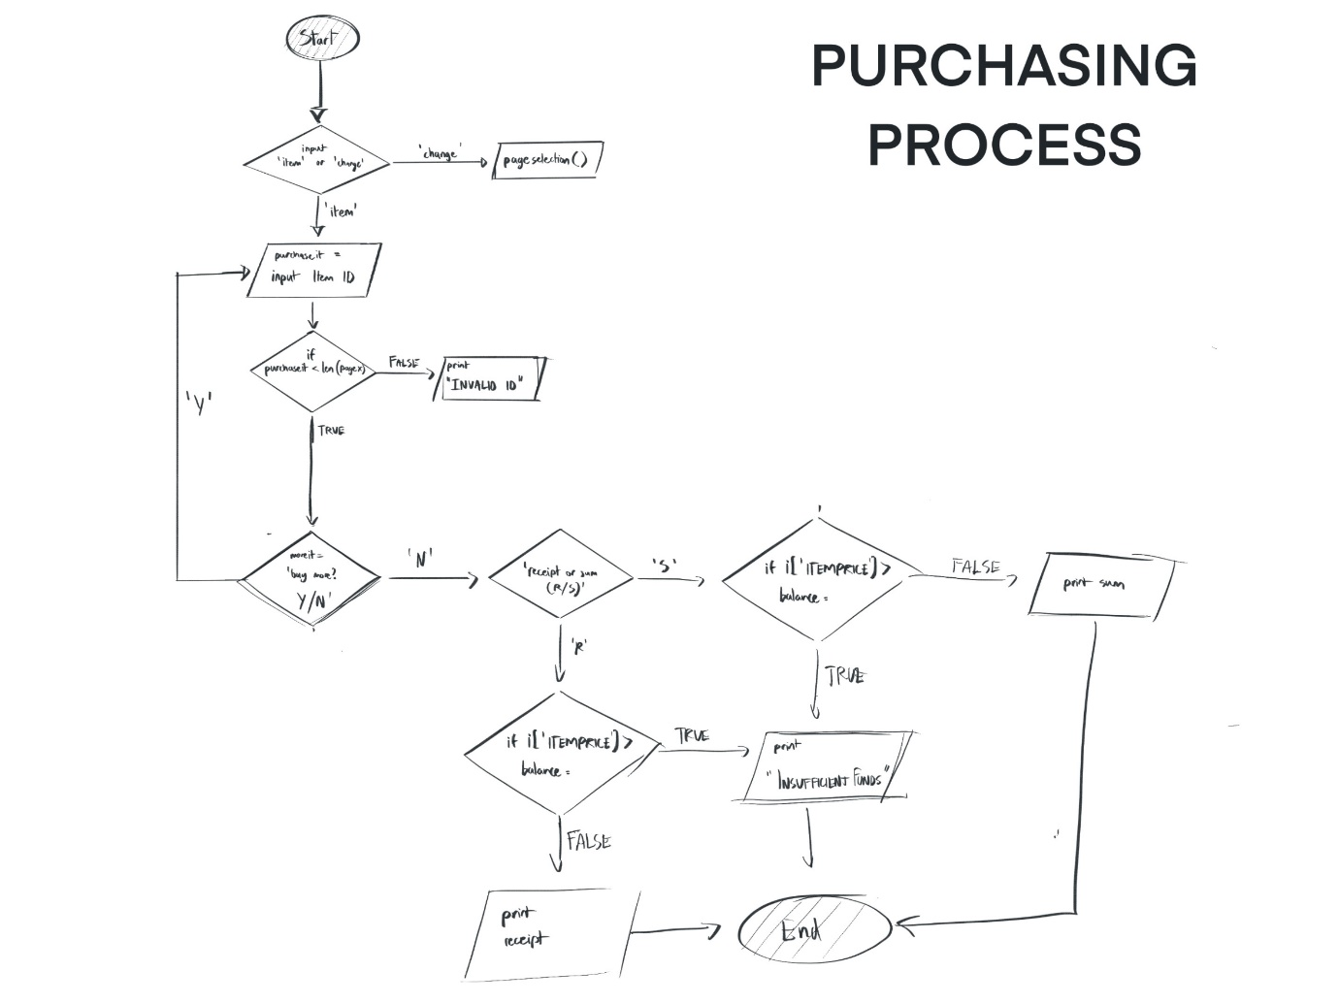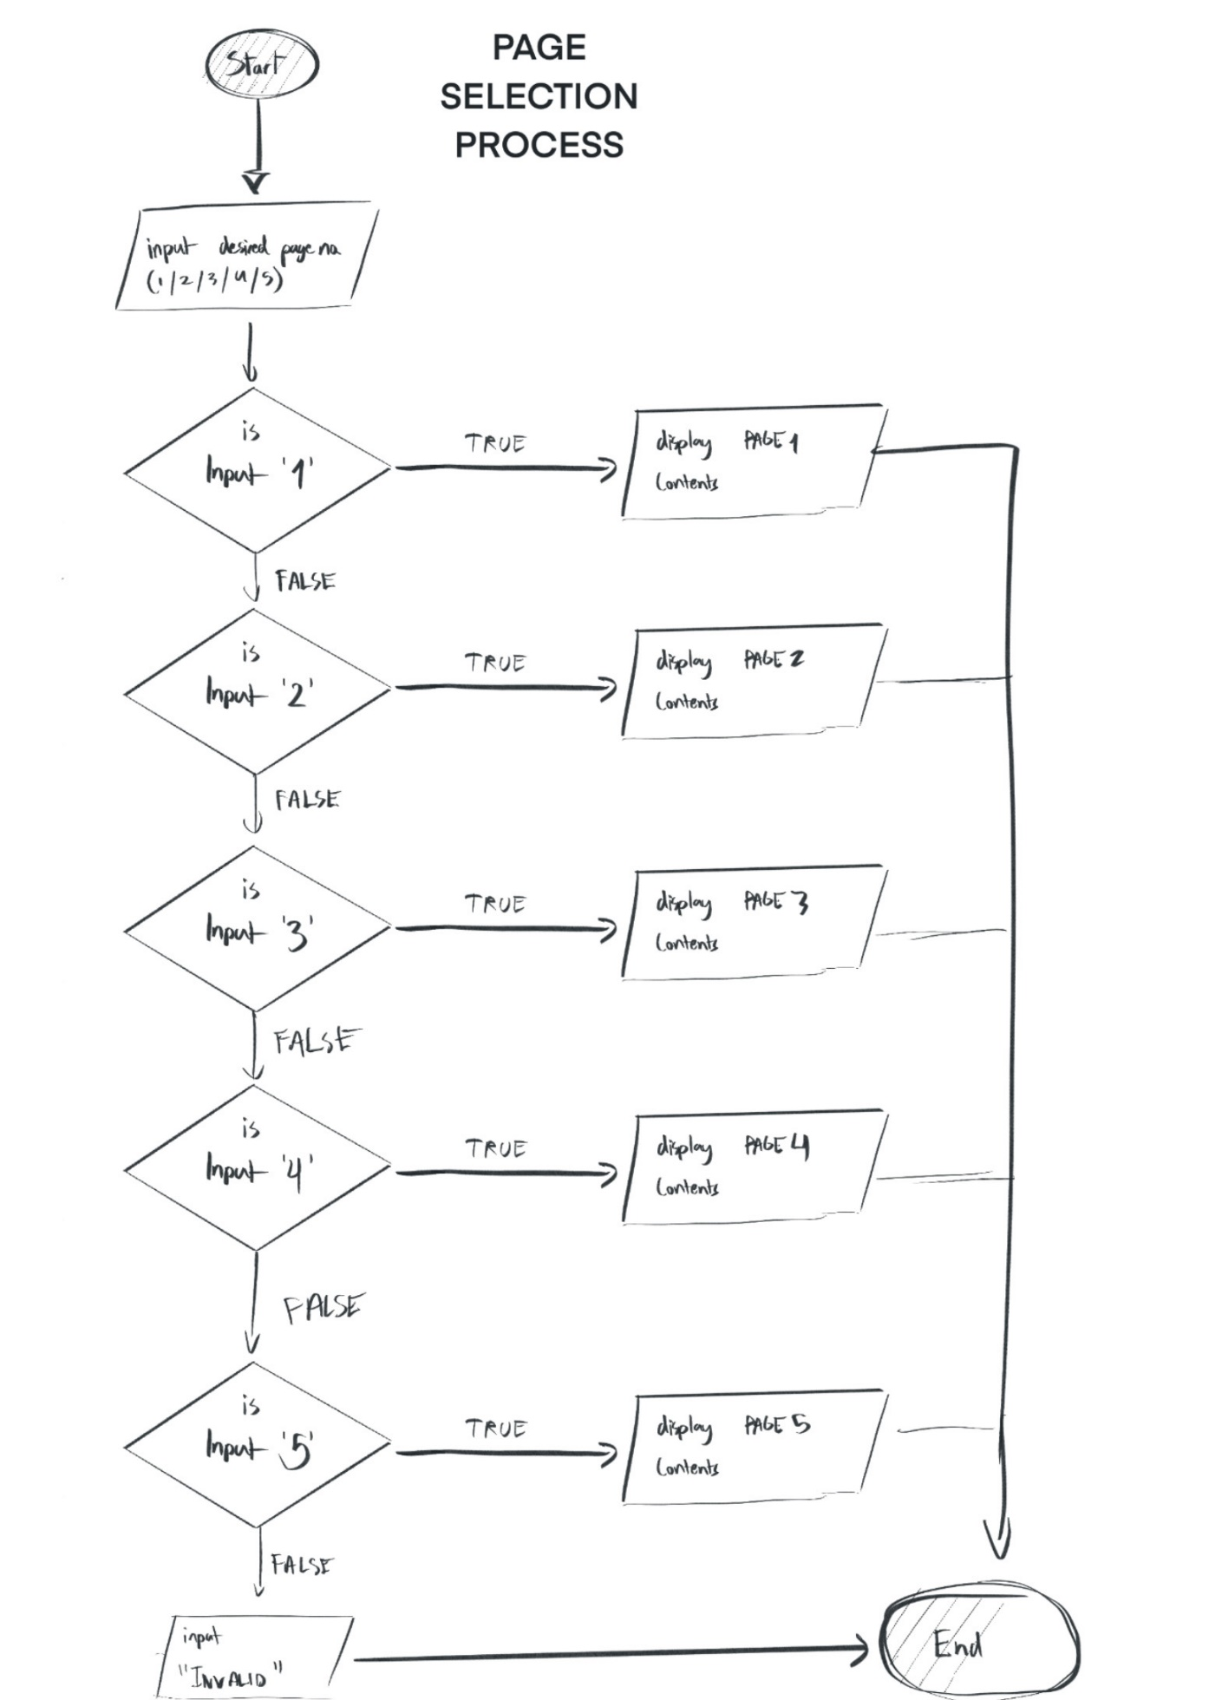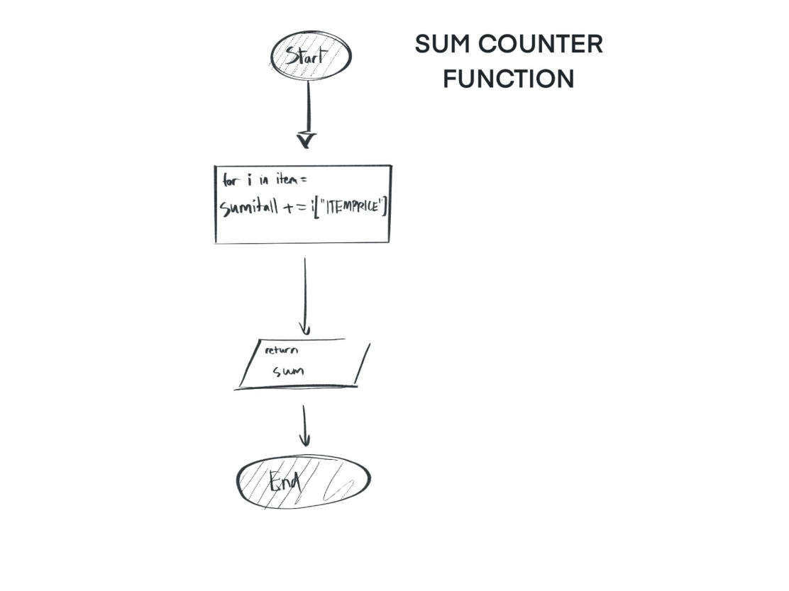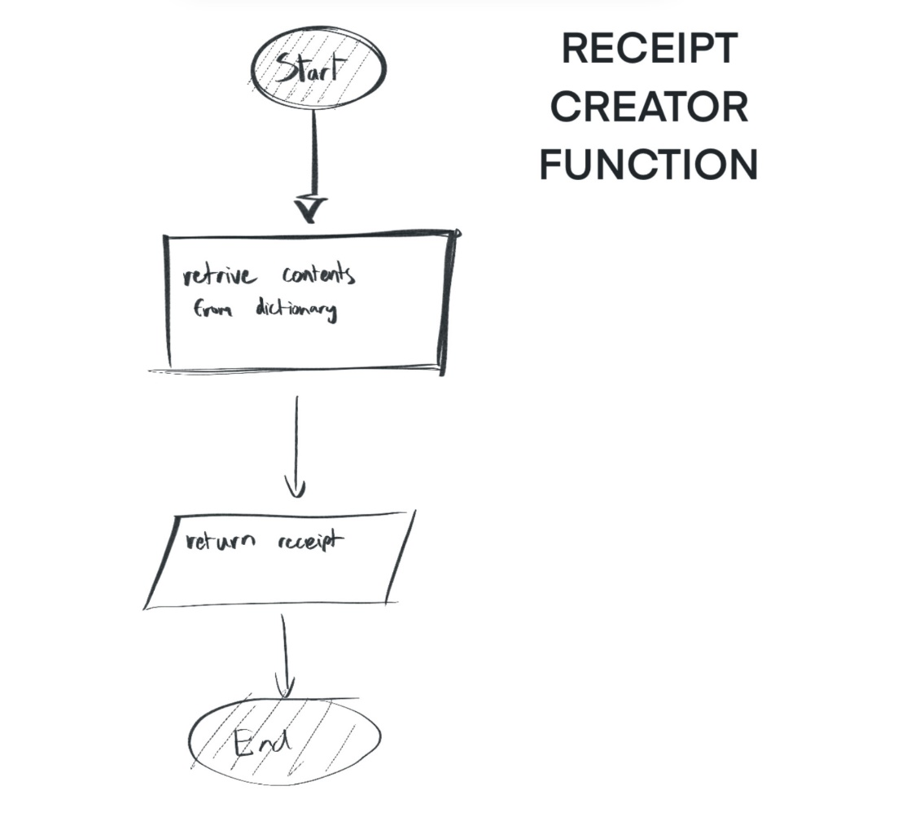

**Technical Description / Walkthrough**

***https://youtu.be/RRxajcFtBIQ***

**Critical Reflections**

I write this critical reflection based on my personal opinions of my entire work. To begin with, the most compelling part of my vending machine has to be the page change feature, initially I thought it would be relatively difficult to somewhat pull it off, and lengthy because there are a total of 5 pages in the vending machine and each page is independently coded. I was proven wrong, it was more simple than I had anticipated. Along the way I had learned and managed to improve the code over time until it reached a point I am satisfied with it. A prototype was 560+ lines, while the final is at only 380+. However, despite its flawless looks and functions it could have room for improvement, that I wish to look into in the future as my current level of knowledge is relatively limited. What I wished to improve is somewhat finding a way to implement a more convenient functioning for the page change. That is only one thing I see that would be needed to improve however I myself couldn't find a way to do how. I would certainly desire learning more useful python programs along the way that could easily help me mitigate these issues sometime in the future. However, overall I am pretty satisfied with the current work I had put into. From the purchasing process to the whole page change feature. I had a fun experience doing all this work overall and satisfied of its outcome.

**APPENDIX**

balance = 0

page1 = [

{

"ITEMID": 0,

"ITEMNAME": "SigmaBar",

'ITEMPRICE': 5,

},{

"ITEMID": 1,

"ITEMNAME": "US Military Military Energy Gum",

'ITEMPRICE': 35,

},{

"ITEMID": 2,

"ITEMNAME": "SlimJim",

'ITEMPRICE': 3,

},{

"ITEMID": 3,

"ITEMNAME": "Mars Bar",

'ITEMPRICE': 2,

},{

"ITEMID": 4,

"ITEMNAME": "Lays Chips",

'ITEMPRICE': 10,

},

]

page2 = [

{

"ITEMID": 0,

"ITEMNAME": "Rotisserie Chicken",

'ITEMPRICE': 25,

},{

"ITEMID": 1,

"ITEMNAME": "Lasagna",

'ITEMPRICE': 25,

},{

"ITEMID": 2,

"ITEMNAME": "12 inch Cheese Pizza",

'ITEMPRICE': 30,

},{

"ITEMID": 3,

"ITEMNAME": "12 PCs. Fried Chicken Bucket",

'ITEMPRICE': 35,

},{

"ITEMID": 4,

"ITEMNAME": "Microwavable Salisbury Steak",

'ITEMPRICE': 15,

},

]

page3 = [

{

"ITEMID": 0,

"ITEMNAME": "Coca Cola",

'ITEMPRICE': 2,

},{

"ITEMID": 1,

"ITEMNAME": "Root Beer",

'ITEMPRICE': 2,

},{

"ITEMID": 2,

"ITEMNAME": "Water",

'ITEMPRICE': 1,

},{

"ITEMID": 3,

"ITEMNAME": "Bottled Milkshake",

'ITEMPRICE': 67,

},{

"ITEMID": 4,

"ITEMNAME": "Iced Frappe",

'ITEMPRICE': 100,

},

]

page4 = [

{

"ITEMID": 0,

"ITEMNAME": "Coffee",

'ITEMPRICE': 3,

},{

"ITEMID": 1,

"ITEMNAME": "Tea",

'ITEMPRICE': 3,

},{

"ITEMID": 2,

"ITEMNAME": "Karak Chai",

'ITEMPRICE': 1,

},{

"ITEMID": 3,

"ITEMNAME": "Green Tea",

'ITEMPRICE': 2,

},{

"ITEMID": 4,

"ITEMNAME": "Hot Chocolate",

'ITEMPRICE': 3,

},

]

page5 = [

{

"ITEMID": 0,

"ITEMNAME": "Sigma's Vanilla Ice Popsicle",

'ITEMPRICE': 5,

},{

"ITEMID": 1,

"ITEMNAME": "Butterscotch Ice Cone",

'ITEMPRICE': 3,

},{

"ITEMID": 2,

"ITEMNAME": "Sponge Man Ice Cone",

'ITEMPRICE': 4,

},{

"ITEMID": 3,

"ITEMNAME": "Ice Cream Sandwich",

'ITEMPRICE': 5,

},{

"ITEMID": 4,

"ITEMNAME": "Juice Cold Stick",

'ITEMPRICE': 3,

},

]

item = []

receipt = """

\t--------- RECEIPT ----------

"""

run = True

def PAGE1PURCHASE(page1, run, item):

cou = 0

selection = str(input("Do you wish to purchase an item or change page (item/change): \n"))

sel = selection.lower()

if sel == "item":

while run:

purchaseit = int(input("\nEnter Item ID: "))

if purchaseit < len(page1):

item.append(page1[purchaseit])

else:

print("INVALID ITEM ID")

moreit = str(input("\nPurchase additional items? (Y/N)\n"))

low = moreit.lower()

if low == "n":

run = False

receiptv = input(("\nReceipt or Total Sum (R/S): \n"))

dec = receiptv.lower()

if dec == "r":

for i in item:

if i['ITEMPRICE'] > balance:

cou = cou + 1

else:

print(creceipt(item, receipt))

if cou > 0:

print ("INSUFFICIENT FUNDS")

elif dec == "s":

for i in item:

if i['ITEMPRICE'] > balance:

cou = cou + 1

else:

print(sumitall(item))

if cou > 0:

print ("INSUFFICIENT FUNDS")

else:

pageselection()

def PAGE2PURCHASE(page1, run, item):

cou = 0

selection = str(input("Do you wish to purchase an item or change page (item/change): \n"))

sel = selection.lower()

if sel == "item":

while run:

purchaseit = int(input("\nEnter Item ID: "))

if purchaseit < len(page2):

item.append(page2[purchaseit])

else:

print("INVALID ITEM ID")

moreit = str(input("\nPurchase additional items? (Y/N)\n"))

low = moreit.lower()

if low == "n":

run = False

receiptv = input(("\nReceipt or Total Sum (R/S): \n"))

dec = receiptv.lower()

if dec == "r":

for i in item:

if i['ITEMPRICE'] > balance:

cou = cou + 1

else:

print(creceipt(item, receipt))

if cou > 0:

print ("INSUFFICIENT FUNDS")

elif dec == "s":

for i in item:

if i['ITEMPRICE'] > balance:

cou = cou + 1

else:

print(sumitall(item))

if cou > 0:

print ("INSUFFICIENT FUNDS")

else:

pageselection()

def PAGE3PURCHASE(page1, run, item):

cou = 0

selection = str(input("Do you wish to purchase an item or change page (item/change): \n"))

sel = selection.lower()

if sel == "item":

while run:

purchaseit = int(input("\nEnter Item ID: "))

if purchaseit < len(page3):

item.append(page3[purchaseit])

else:

print("INVALID ITEM ID")

moreit = str(input("\nPurchase additional items? (Y/N)\n"))

low = moreit.lower()

if low == "n":

run = False

receiptv = input(("\nReceipt or Total Sum (R/S): \n"))

dec = receiptv.lower()

if dec == "r":

for i in item:

if i['ITEMPRICE'] > balance:

cou = cou + 1

else:

print(creceipt(item, receipt))

if cou > 0:

print ("INSUFFICIENT FUNDS")

elif dec == "s":

for i in item:

if i['ITEMPRICE'] > balance:

cou = cou + 1

else:

print(sumitall(item))

if cou > 0:

print ("INSUFFICIENT FUNDS")

else:

pageselection()

def PAGE4PURCHASE(page1, run, item):

cou = 0

selection = str(input("Do you wish to purchase an item or change page (item/change): \n"))

sel = selection.lower()

if sel == "item":

while run:

purchaseit = int(input("\nEnter Item ID: "))

if purchaseit < len(page4):

item.append(page4[purchaseit])

else:

print("INVALID ITEM ID")

moreit = str(input("\nPurchase additional items? (Y/N)\n"))

low = moreit.lower()

if low == "n":

run = False

receiptv = input(("\nReceipt or Total Sum (R/S): \n"))

dec = receiptv.lower()

if dec == "r":

for i in item:

if i['ITEMPRICE'] > balance:

cou = cou + 1

else:

print(creceipt(item, receipt))

if cou > 0:

print ("INSUFFICIENT FUNDS")

elif dec == "s":

for i in item:

if i['ITEMPRICE'] > balance:

cou = cou + 1

else:

print(sumitall(item))

if cou > 0:

print ("INSUFFICIENT FUNDS")

else:

pageselection()

def PAGE5PURCHASE(page1, run, item):

cou = 0

selection = str(input("Do you wish to purchase an item or change page (item/change): \n"))

sel = selection.lower()

if sel == "item":

while run:

purchaseit = int(input("\nEnter Item ID: "))

if purchaseit < len(page5):

item.append(page5[purchaseit])

else:

print("INVALID ITEM ID")

moreit = str(input("\nPurchase additional items? (Y/N)\n"))

low = moreit.lower()

if low == "n":

run = False

receiptv = input(("\nReceipt or Total Sum (R/S): \n"))

dec = receiptv.lower()

if dec == "r":

for i in item:

if i['ITEMPRICE'] > balance:

cou = cou + 1

else:

print(creceipt(item, receipt))

if cou > 0:

print ("INSUFFICIENT FUNDS")

elif dec == "s":

for i in item:

if i['ITEMPRICE'] > balance:

cou = cou + 1

else:

print(sumitall(item))

if cou > 0:

print ("INSUFFICIENT FUNDS")

else:

pageselection()

def sumitall(item):

sumitall = 0

for i in item:

sumitall += i["ITEMPRICE"]

return sumitall

def creceipt(item, receipt):

for i in item:

receipt += f"""

\tITEM ID [{i["ITEMID"]}] - [ {i["ITEMNAME"]} -- {i['ITEMPRICE']} Credit(s) ]

"""

receipt += f"""

\tTOTAL PAYMENT --- {sumitall(item)} Credit(s)

You Currently have {balance - sumitall(item)} Credit(s)

"""

return receipt

def pageselection():

print ("""

\n[ -------------- [ PAGE SELECTION ] -------------- ]

[ [PAGE 1] - Light Snacks - ]

[ [PAGE 2] - Readymade Meals - ]

[ [PAGE 3] - Cold Drinks - ]

[ [PAGE 4] - Hot Drinks - ]

[ [PAGE 5] - Dessert Snacks - ]

""")

paslect = int(input("\n ---------- [ Select which page do you wish to change to: (1/2/3/4/5) ] ---------- \n"))

if paslect == 1:

print ("\n[ -------------- PAGE 1 = LIGHT SNACKS -------------- ]")

for i in page1:

print(

f"\n[ [ITEM ID]: {i['ITEMID']} [ITEM]: {i['ITEMNAME']} [COST]: {i['ITEMPRICE']} Credit(s) ]")

print(f"\n{PAGE1PURCHASE(page1, run, item)}")

elif paslect == 2:

print ("\n[ -------------- PAGE 2 = READYMADE MEALS -------------- ]")

for i in page2:

print(

f"\n[ [ITEM ID]: {i['ITEMID']} [ITEM]: {i['ITEMNAME']} [COST]: {i['ITEMPRICE']} Credit(s) ]")

print(f"\n{PAGE2PURCHASE(page2, run, item)}")

elif paslect == 3:

print ("\n[ -------------- PAGE 3 = COLD DRINKS -------------- ]")

for i in page3:

print(

f"\n[ [ITEM ID]: {i['ITEMID']} [ITEM]: {i['ITEMNAME']} [COST]: {i['ITEMPRICE']} Credit(s) ]")

print(f"\n{PAGE3PURCHASE(page3, run, item)}")

elif paslect == 4:

print ("\n[ -------------- PAGE 4 = HOT DRINKS -------------- ]")

for i in page4:

print(

f"\n[ [ITEM ID]: {i['ITEMID']} [ITEM]: {i['ITEMNAME']} [COST]: {i['ITEMPRICE']} Credit(s) ]")

print(f"\n{PAGE4PURCHASE(page4, run, item)}")

elif paslect == 5:

print ("\n[ -------------- PAGE 5 = DESSERT SNACKS -------------- ]")

for i in page5:

print(

f"\n[ [ITEM ID]: {i['ITEMID']} [ITEM]: {i['ITEMNAME']} [COST]: {i['ITEMPRICE']} Credit(s) ]")

print(f"\n{PAGE5PURCHASE(page5, run, item)}")

else:

print ("Invalid")

try:

balinput = int(input("Insert your Budget (MAX. 2750)\n"))

while balinput > 2750:

print ("The amount inputted exceeds the limit.")

balinput = int(input("Insert your Budget (MAX. 2750)\n"))

else:

print ("\n--------------- Welcome to THE Vending Machine! --------------- \n\n\tWe have a wide array of refreshments!")

print ("\n[ -------------- PAGE 1 = LIGHT SNACKS -------------- ]")

for i in page1:

print(

f"\n[ [ITEM ID]: {i['ITEMID']} [ITEM]: {i['ITEMNAME']} [COST]: {i['ITEMPRICE']} Credits ]")

balance = balinput

print (f"\n\tYour balance is currently {balance} Credits")

print ("\n[--------------- Select your Refreshments! ---------------] ")

PAGE1PURCHASE(page1, run, item)

except ValueError:

print ("Invalid value, insert an integer.")